School Health Webinar Series

This is a monthly educational webinar series for Maine school health professionals and pediatricians. The webinar series aims to enhance knowledge and promote collaboration among health professionals who support student health.
Each session provides 1 contact hour, for a total of 5 hours.
Titles of Sessions
The Digital Dilemma: Supporting Youth Mental Health in an AI-Driven World;
Supporting Self-Management in Diabetes;
Tuberculosis 101;
School Vaccine Requirements: What They Are, Why They Matter, and How to Implement Them in Challenging Times;
Autism Spectrum Disorders: Challenges, Strengths, and Strategies in the Educational Setting.

If you are not already enrolled as an EnGiNE approved user, enrolling in the Webinar Series is a short process.
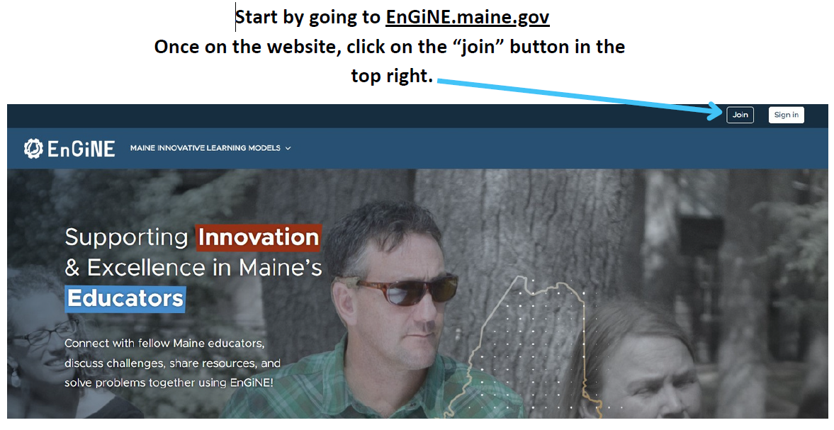

After clicking “Join”, there is additional information that you need to fill in.
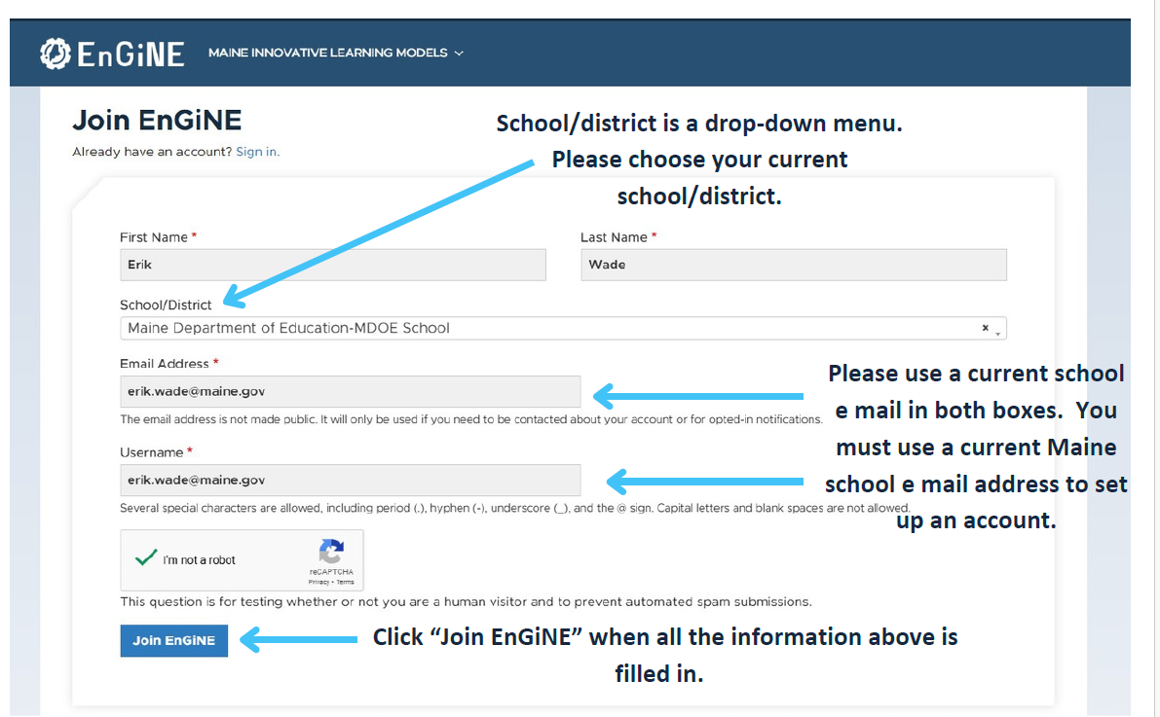
If you are not employed by a Maine school and have been invited by Maine AAP or Maine DOE to participate in this webinar series, you will select, “A Community Organization – Not a School or SAU”. Enter your email address and use your email address as your username.

After clicking “Join EnGiNE”, you should see the following screen. You will receive an email confirming your reason for joining EnGiNE. You can respond, “I want to take the School Health Webinar Series and received an invitation”.

For those with no Maine school email, you will be added to EnGiNE as a community member and can access the webinar series.

Bookmark this School Health Webinar Series 2025-26 link

